



**Intellectual Property Management Plan**

**February 28, 2011**

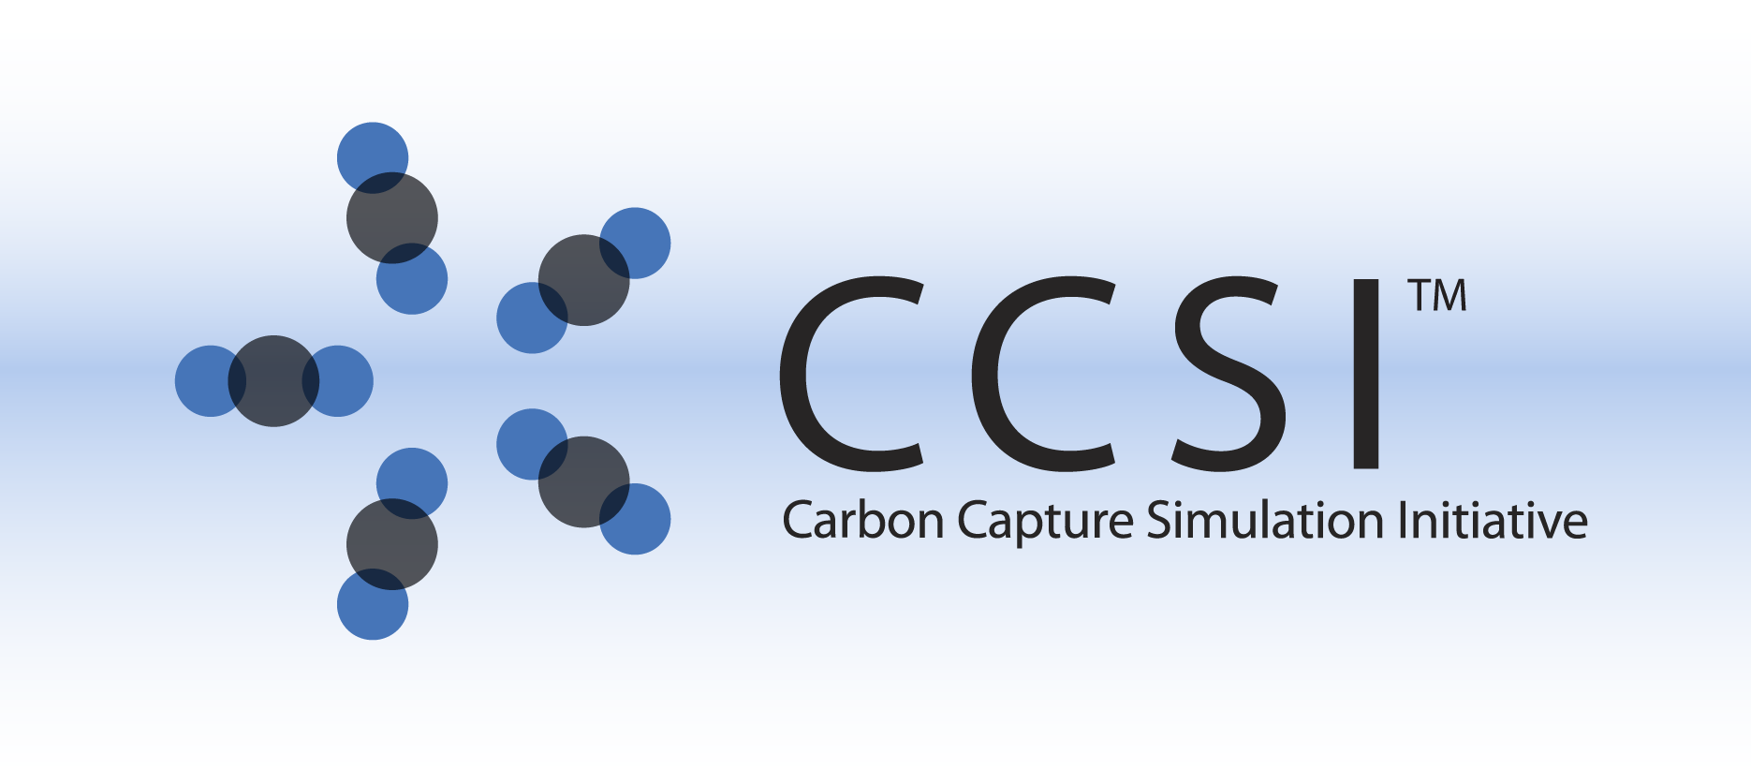

iREVEAL INSTALLATION GUIDE

Version 2.0.0

February 2018

Copyright (c) 2012 - 2018

**Copyright Notice**

iREVEAL was produced under the DOE Carbon Capture Simulation Initiative (CCSI), and is copyright (c) 2012 - 2018 by the software owners: Oak Ridge Institute for Science and Education (ORISE), Los Alamos National Security, LLC., Lawrence Livermore National Security, LLC., The Regents of the University of California, through Lawrence Berkeley National Laboratory, Battelle Memorial Institute, Pacific Northwest Division through Pacific Northwest National Laboratory, Carnegie Mellon University, West Virginia University, Boston University, the Trustees of Princeton University, The University of Texas at Austin, URS Energy & Construction, Inc., et al.. All rights reserved.

NOTICE. This Software was developed under funding from the U.S. Department of Energy and the U.S. Government consequently retains certain rights. As such, the U.S. Government has been granted for itself and others acting on its behalf a paid-up, nonexclusive, irrevocable, worldwide license in the Software to reproduce, distribute copies to the public, prepare derivative works, and perform publicly and display publicly, and to permit other to do so.

**License Agreement**

iREVEAL Copyright (c) 2012 - 2018, by the software owners: Oak Ridge Institute for Science and Education (ORISE), Los Alamos National Security, LLC., Lawrence Livermore National Security, LLC., The Regents of the University of California, through Lawrence Berkeley National Laboratory, Battelle Memorial Institute, Pacific Northwest Division through Pacific Northwest National Laboratory, Carnegie Mellon University, West Virginia University, Boston University, the Trustees of Princeton University, The University of Texas at Austin, URS Energy & Construction, Inc., et al. All rights reserved.

Redistribution and use in source and binary forms, with or without modification, are permitted provided that the following conditions are met:

1. Redistributions of source code must retain the above copyright notice, this list of conditions and the following disclaimer.
2. Redistributions in binary form must reproduce the above copyright notice, this list of conditions and the following disclaimer in the documentation and/or other materials provided with the distribution.
3. Neither the name of the Carbon Capture Simulation Initiative, U.S. Dept. of Energy, the National Energy Technology Laboratory, Oak Ridge Institute for Science and Education (ORISE), Los Alamos National Security, LLC., Lawrence Livermore National Security, LLC., the University of California, Lawrence Berkeley National Laboratory, Battelle Memorial Institute, Pacific Northwest National Laboratory, Carnegie Mellon University, West Virginia University, Boston University, the Trustees of Princeton University, the University of Texas at Austin, URS Energy & Construction, Inc., nor the names of its contributors may be used to endorse or promote products derived from this software without specific prior written permission.

THIS SOFTWARE IS PROVIDED BY THE COPYRIGHT HOLDERS AND CONTRIBUTORS "AS IS" AND ANY EXPRESS OR IMPLIED WARRANTIES, INCLUDING, BUT NOT LIMITED TO, THE IMPLIED WARRANTIES OF MERCHANTABILITY AND FITNESS FOR A PARTICULAR PURPOSE ARE DISCLAIMED. IN NO EVENT SHALL THE COPYRIGHT OWNER OR CONTRIBUTORS BE LIABLE FOR ANY DIRECT, INDIRECT, INCIDENTAL, SPECIAL, EXEMPLARY, OR CONSEQUENTIAL DAMAGES (INCLUDING, BUT NOT LIMITED TO, PROCUREMENT OF SUBSTITUTE GOODS OR SERVICES; LOSS OF USE, DATA, OR PROFITS; OR BUSINESS INTERRUPTION) HOWEVER CAUSED AND ON ANY THEORY OF LIABILITY, WHETHER IN CONTRACT, STRICT LIABILITY, OR TORT (INCLUDING NEGLIGENCE OR OTHERWISE) ARISING IN ANY WAY OUT OF THE USE OF THIS SOFTWARE, EVEN IF ADVISED OF THE POSSIBILITY OF SUCH DAMAGE.

You are under no obligation whatsoever to provide any bug fixes, patches, or upgrades to the features, functionality or performance of the source code ("Enhancements") to anyone; however, if you choose to make your Enhancements available either publicly, or directly to Lawrence Berkeley National Laboratory, without imposing a separate written license agreement for such Enhancements, then you hereby grant the following license: a non-exclusive, royalty-free perpetual license to install, use, modify, prepare derivative works, incorporate into other computer software, distribute, and sublicense such enhancements or derivative works thereof, in binary and source code form. This material was produced under the DOE Carbon Capture Simulation Initiative

Table of Contents

1. Introduction 1

2. Prerequisites 1

2.1. Hardware 1

2.2. Software 1

3. Basic Installation 1

3.1. Third Party Software Installation 1

3.1.1 Java installation 1

3.1.2 Python Installation 2

3.1.3 FOQUS Installation 2

3.2. Product Build ( Optional, only if building latest code from svn manually) 3

3.2.1. Creating iREVEAL zip file 3

3.3. Product Installation 4

4. Installation Test 4

5. Installation Problems 5

5.1. Known Issues/Fixes 5

5.2. Reporting Installation issues 5

# Introduction

iREVEAL framework is a toolkit for reduced order modeling of scientific simulations. It has been developed under Carbon Capture Simulation Initiative for response surface generation of Computational Fluid Dynamics(CFD) models and can be used for MFIX(Multiphase Flow with Interphase Exchanges) Barracuda, Fluent or any other CFD model. However it is a generic framework and can be customized for use in other domains easily as well.

# Prerequisites

## Hardware

N/A

## Software

iREVEAL has been tested on 32 bit and 64 bit windows platform. iREVEAL requires the Java Runtime Environment, Python, and CCSI’s FOQUS tool. The list of software needed for the install is provided in Table 1.

Note: Users are expected to run their own CFD simulations

|  |  |  |
| --- | --- | --- |
| **Package** | **Online Installation Link** | **Version required** |
| 1. Python | http://python.org/download/ | 2.7 (or higher) |
| 1. Java | Oracle.org | 1.6 or higher |
| 1. FOQUS | https://www.acceleratecarboncapture.org/drupal/product/FOQUS_bundle | 2014.10.0 |

Table 1: Getting Required Packages

## Software packages for integrating ROM in Aspen Plus Simulation:

To integrate a iREVEAL generated reduced order model in Aspen Plus for process simulation user needs following software:

1. Aspen Plus 7.3
2. Visual Studio 2008

# Basic Installation

## Third Party Software Installation

### 3.1.1 Java installation

To use iREVEAL, user needs to have java version 6 (**java -1.7)** installed on the system. To check if java is installed, open command line and on prompt check for java version, you should get appropriate response listing java version. For e.g.,

* java -version

java version 1.7.x.x <build 1.6.x.x>

Java(SE) TM Runtime Environment

If JDK/JRE is not already installed, please install appropriate 32bit or 64 bit JRE

(download link- http://www.oracle.com/technetwork/java/javase/downloads/index.html)

Add JAVA_HOME to your PATH environment variable thereafter (refer to section 4.2 for adding environment variables).

iREVEAL also requires Python2.7 or higher to be installed on the user’s system. Follow the instructions on python website for installation <https://www.python.org/download/releases/2.7/>

The user should set environment variables as explained in section 3.2 and do package installation checks as mentioned in section 5 before proceeding further.

### 3.1.2 Python Installation

FOQUS requires Python 2.7 or greater. You can check to see if it is installed on your machine by looking for “Python 2.7” on your start menu.

To install Python go to <https://www.python.org/downloads/release/python-278/> and download the proper installer for your system. Simply run it and take the defaults for installation.

For iREVEAL to use Python, python must be in your windows PATH variable. (This allows FOQUS and iREVEAL to find the python executable.) To put Python in your PATH:

1. Right click on MyComputer, and select Properties.
2. Switch to the Advanced Tab.
3. Click the ‘Environment Variables…’ button.
4. Find the PATH variable in the “System variables” box
5. Click edit.
6. At the end of the text in the “Variable value:” box, add: “;C:\Python27\” (The semicolon is required.)
7. Click ‘OK’.

For FOQUS to use Python, python must be associated with the .py file extension. Python sets this by default during installation, but if you find that iReveal and FOQUS are not running surrogates correctly, please see the “Known Issues” section of the iREVEAL User Manual.

### 3.1.3 FOQUS Installation

User should finish installing the CCSI FOQUS tool and its dependencies before proceeding with the iREVEAL installation. Please refer to the FOQUS installation manuals for details. It may be found with the installer at <https://www.acceleratecarboncapture.org/drupal/product/FOQUS_bundle>

### 3.1.4 Visual Studio and Aspen Installation

### To integrate the CFD surrogate model generated in iREVEAL, user needs to install Microsoft

### Visual Studio 2008 and Aspen Plus 7.3. User should install Microsoft visual studio 2008 first

### followed by Aspen Plus 7.3 . This enables Aspen to pick up the visual studio path correctly.

## Product Build ( Optional, follow only if building latest code from svn manually)

Most users need not perform this step. User can download the iREVEAL installer directly from CCSI product page and skip section 3.2.

To build iREVEAL jar file directly from source, the user may follow the instructions below

Option 1:

1. Checkout the iREVEAL code from svn:
   1. <https://svn.acceleratecarboncapture.org/svn/projects/iREVEAL/trunk/>
2. Ensure you have JDK( Java Development Kit) installed ( not just JRE)
3. to simplify discussion, assuming the directory you checked out code is *$iREVEAL_HOME*
4. Open cmd.exe on windows and ‘cd’ to *$iREVEAL_HOME/iREVEAL*
5. Execute build.bat on command line:
   1. *$iREVEAL_HOME/iREVEAL>build.bat*
   2. And press “Enter”
6. The above step will create a bin directory and a iREVEAL.jar under *$iREVEAL_HOME/iREVEAL*

These steps should create a runnable jar file for iREVEAL project. Please note that if your system cannot find “javac” or “jar” command check you system “$PATH” environment variable and ensure JAVA is installed, JAVA_HOME is defined and JAVA_HOME/bin is added to your $PATH environment variable.

**Alternate option to build jar file using ANT:** If you would like to use ANT to build the jar file from source code, you can do that by using buid.xml file in *$iREVEAL_HOME/iREVEAL directory as follows:*

* Execute build.xml using ant on command line:
  + *$iREVEAL_HOME/iREVEAL>ant*
  + And press “Enter”

This should have the same effect as described above after steps 1-4.

## Creating iREVEAL zip file

iREVEAL zip file consists of iREVEAL.jar file created in previos step and the python source code. To create zip file :

1. Create jar file as mentioned in step 3.3.1
2. Copy “config” folder at <https://svn.acceleratecarboncapture.org/svn/projects/iREVEAL/trunk/iREVEAL/config/>

In the same folder as jar file

1. Zip the jar and “config” folder as iREVEAL.zip

## Product Installation

We recommend installing iREVEAL in a new sub-directory of the user’s home directory. To install iREVEAL all you need to do is unzip the file into the intended directory (user MUST have write access to the directory) and set the path to iREVEAL in FOQUS settings :

1. unzip iREVEAL.zip in a new folder. This will create multiple directories including “iREVEAL” The iREVEAL folder will contain the iREVEAL.jar file, manuals and several other directories.
2. Open FOQUS, select “Session” tab and click on “FOQUS Settings.” At the bottom of the FOQUS window.
3. Below the settings, click the “Edit Setting…” button.
4. The window below should appear. Set iREVEAL_HOME to the directory containing the iREVEAL.jar file.

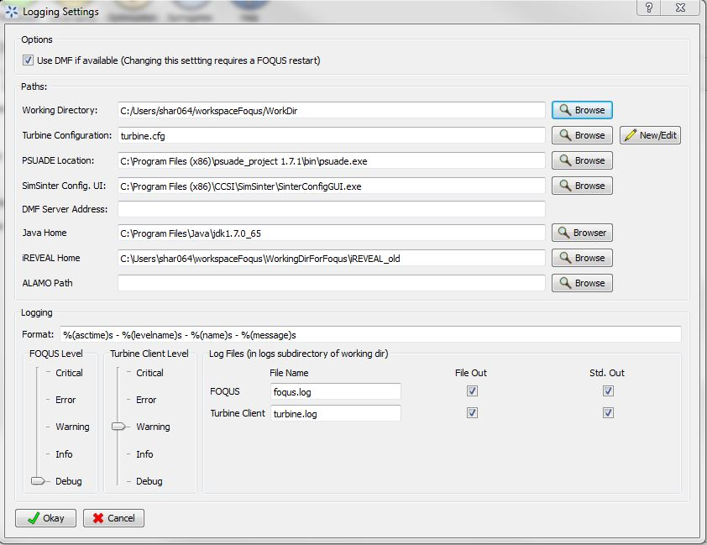Figure 1: Setting iREVEAL Home in FOQUS

# Installation Test

To test iREVEAL installation, please select “Surrogates” tab in FOQUS and select iREVEAL under “Tool:” (as shown below). Click on the green “triangle” button.

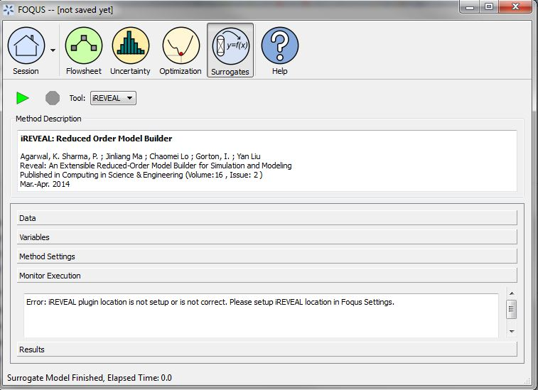Figure 2: Testing external library installation

If iREVEAL were not installed successfully you will see error message under “Monitor Execution” as shown in above picture. If it installed successfully , it will print an error message asking to create a flowsheet.

# Installation Problems

## Known Issues/Fixes

## Reporting Installation issues

Contact [ccsi-support@acceleratecarboncapture.org](mailto:ccsi-support@acceleratecarboncapture.org).

The email of lead development team for this product are :

[Jinliang.Ma@netl.gov](mailto:Jinliang.Ma@netl.gov),

[Xin.Sun@pnnl.gov](mailto:Xin.Sun@pnnl.gov),

[Khushbu.Agarwal@pnnl.gov](mailto:Khushbu.Agarwal@pnnl.gov),

[Poorva.Sharma@pnnl.gov](mailto:Poorva.Sharma@pnnl.gov);